

**Microprocessors & Embedded Systems**

**Fire Fighter**

Ali Qasem (20190829) – NIS Engineering

Ahmad Alqam (20210101) - NIS Engineering

Omar Qarqash (20190444) - NIS Engineering

Supervisor:

Dr. Belal Sababha

Dr. Anastasia Gharib

# Abstract:

This project presents a fireman robot built using MicroC pro for PIC and intended to perform automated fire response. To determine the presence and intensity of a fire, the robot integrates both digital and analog flame sensors. Reliable navigation made possible by precise motor control enables the robot to efficiently locate and extinguish fires. The design's effectiveness and simplicity highlight how automation can be used in real-world firefighting situations, highlighting the possible influence of autonomous systems on emergency response.

# Introduction:

The integration of embedded systems and firefighting technology has resulted in a ground-breaking initiative aimed at improving emergency response capabilities. The intelligent firefighting vehicle is intended to function effectively in conditions that are dynamic and hazardous. This creative project is powered by the PIC 16F8778 microcontroller, which is well-known for its powerful performance and versatility.

With the aid of the PIC 16F8778's cutting-edge characteristics, this project aims to convert a regular automobile into an intelligent firefighting tool that can function on its own. This PIC 16F8778-based firefighting vehicle aims to transform emergency response by combining state-of-the-art sensors, accurate actuation mechanisms, and strategic decision-making algorithms. It also hopes to usher in a new era of efficiency, safety, and technological prowess in firefighting scenarios.

# Mechanical Design:

The following parts were utilized in the design of this fireman embedded systems:

Three front-facing flame sensors, an infrared sensor, a PIC 16F877A, three 3.7-volt batteries, a breadboard, an H-bridge, a battery holder, a servo motor, a water tank, a water pump, a transparent hydraulic hose, and jumper wires.

The intelligent fire engine automatically turns to the right when it detects a fire. The car moves straight ahead if the middle sensor detects a fire directly front of it. The servo motor and water pump work together to precisely spray water on the flames when the fire is getting close. To completely cover the fire area, the servo motor also rotates the hose left and right. An infrared (IR) sensor helps the car avoid obstacles during a straight line by stopping it if something gets in the way. The car's architecture ensures that it reacts to various fire scenarios effectively while also being aware of potential hazards.

Likewise with the left sensor.

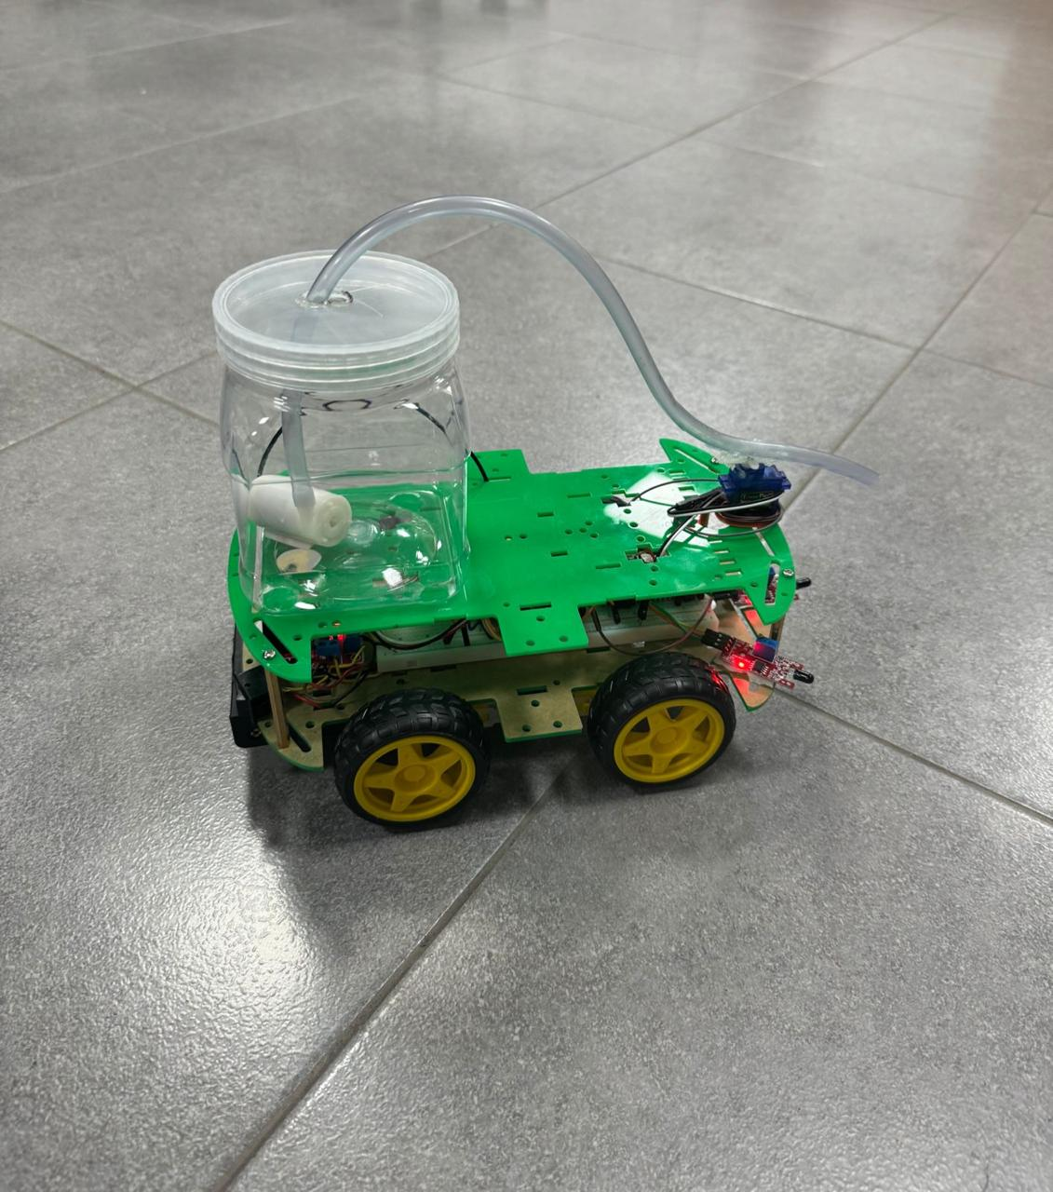

# Electrical Design:

Two Dual H-Bridges have been connected to a 12-volt battery. The microcontroller's VDD pin has been attached to one of the H-Bridges' 5-volt output, and it has been connected in parallel with the servo motor, IR sensor, front, right, and left flame sensors. Next, we linked the servo motor, IR sensor, front, right, and left flame sensors, as well as the H-bridges and microcontroller's VSS pin, in parallel to common ground. The front flame sensor's analogue output is connected to RA0, its digital output to RB7, its right flame sensor's digital output to RB4, its left flame sensor's digital output to RB5, and its IR sensor's output to RD6. These connections are made on the microcontroller.

The inputs in the motor controller H-Bridge are first, followed by the microcontroller's outputs: IN PUT 1 FOR RC6, IN PUT 2 FOR RC7, IN PUT 3 FOR RC4, AND IN PUT 5 FOR RC5. 4. Next, the H-Bridge water pump controller (RB1 TO INPUT). 2. The H-Bridge input 1 in the water pump controller is linked to common ground, allowing A to receive a 5-volt output from the H-Bridge. A and B are additionally connected to the H-Bridge's 5-volt output in the motor controller H-Bridge. The motor controller H-Bridge's outputs are as follows: outputs 1 and 2 go to the left motors, and outputs 3 and 4 go to the right motors. The water pump is connected to H-Bridge outputs 1 and 2 from the water pump controller. The microcontroller's PWM output, or RC2, is coupled to a servo motor.

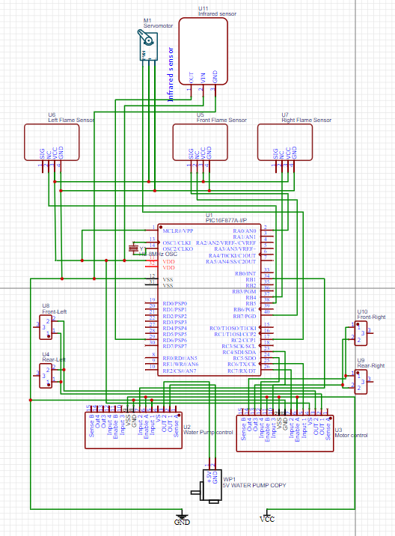

# Software Design:

* We utilized the C programming language and the MicroC Pro for PIC to write our code.
* To implement software PWM for DC Motors, we wrote a millisecond delay function utilizing the TIMER0 overflow interrupt, which overflows every 1 ms and produces an interrupt.
* For the servo motor PWM on port RC2, we employed CCP. using TIMER1.
* A variable called Hi_Lo_Flag (0 or 1) exists. It regulates the PWM signal and modifies it each time a CCP interruption happens.
* The right (digital) left (digital), and front (digital & analog) flame sensors are scanned by the firefighting robot to identify the flame.
* The software launches into the main loop, where it checks the right sensor's digital signal and turns right if there is a flame. If not, it turns right until the front sensor reads the flame's digital signal and turns, causing a variable tick to sound. To avoid an infinite loop, the robot stops rotating if it turns for more than 5000 ms (5 seconds), which is calculated by utilizing the interrupt ms delay starting the timer.
* After then, it scans the flame sensor on the left and uses the same methodology as the sensor on the right.
* Following this, have a look at the front flame sensor's analog voltage. Every time the flame strength grows, the voltage falls, and it varies from 0 to 1023.
* Proceed until the strength is appropriate (in our case, 100) if there is a flame but it is weak.
* If the intensity of the flame is too great, move rearward until the location is appropriate.
* Next, begin extinguishing if the flame strength is appropriate.
* The robot always reads the IR sensor before moving forward to avoid colliding with obstacles and coming to a stop.
* The procedure for extinguishing a fire involves first determining whether the flame strength is sufficient, and then it turns on the water pump and servo motor, which alternately rotate between 0 and 180 revolutions per second until the fire is extinguished.
* 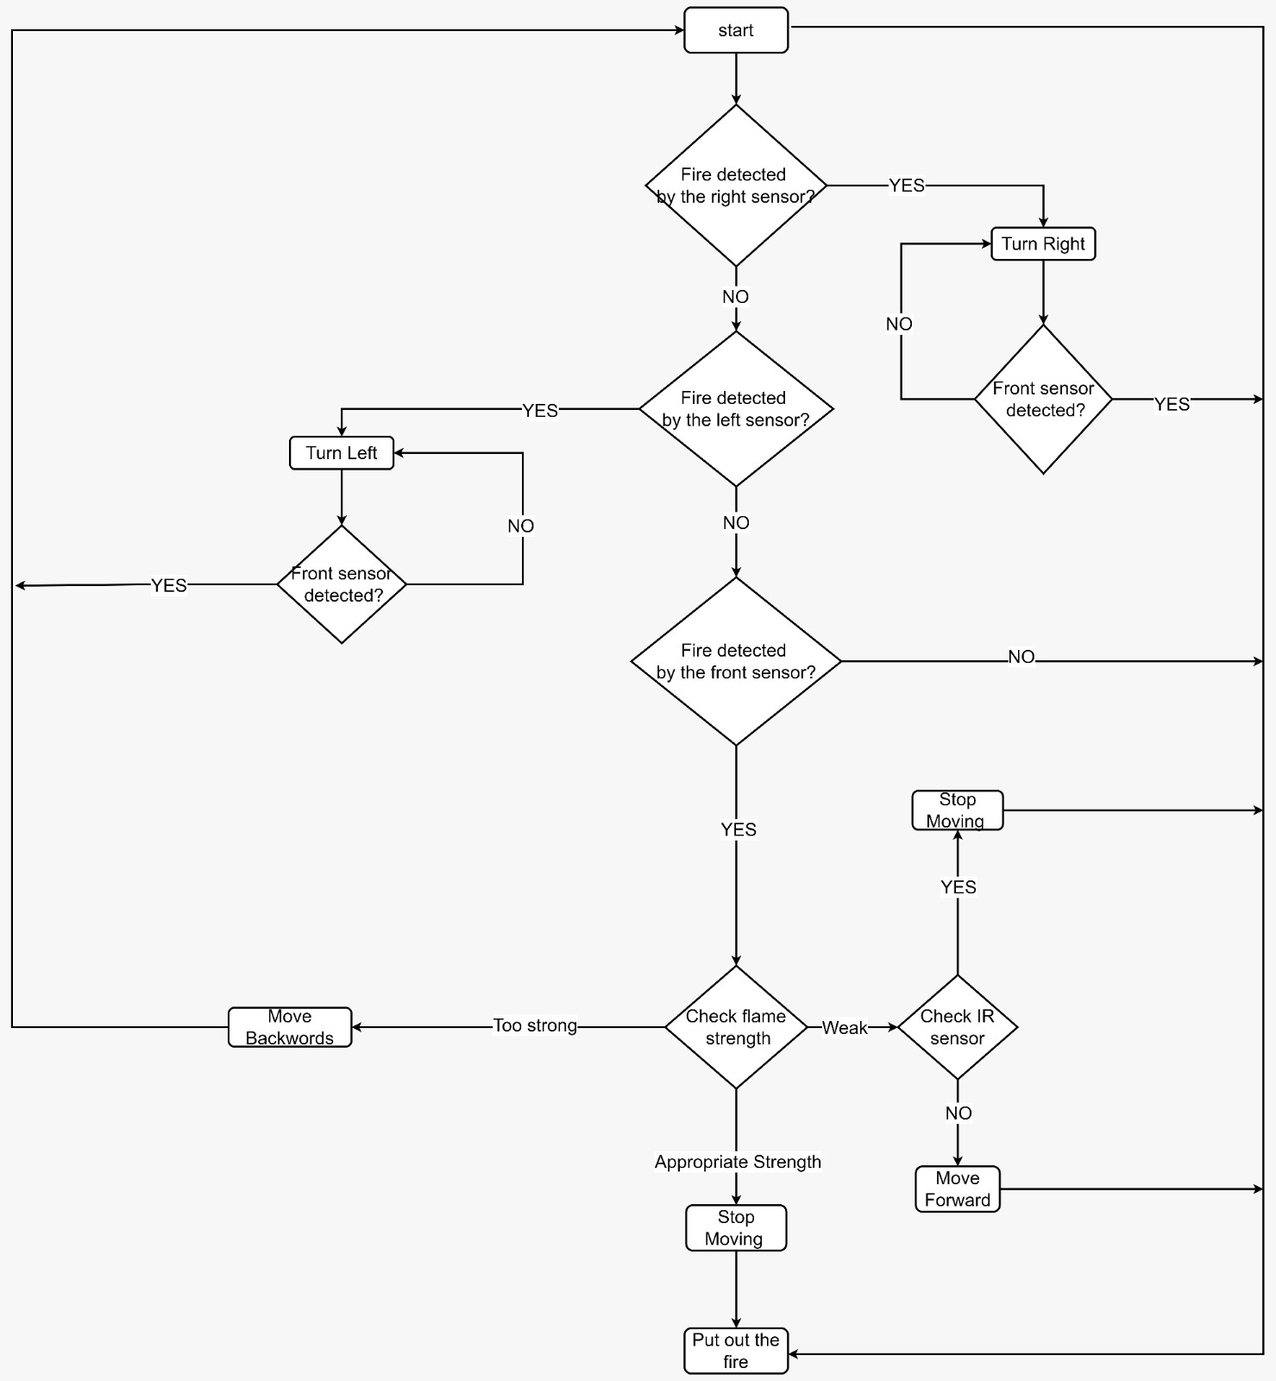To completely contain the fire, the servo motor is equipped with a water hose.

**Problems and Recommendations:**

The robot will stop at a great distance when the flame gets too strong because it has reached the appropriate strength where it should stop, but it stops much farther away than the fire. Therefore, we need more useful sensors to detect fire and integrate the robot with machine learning so it can accurately distinguish between different fire intensities. The current flame sensors are not very practical.

The robot's movement is slowed down by the weight of the water tank, which is the second issue. To be able to endure fire, the robot needs to be constructed of materials resistant to fire.

**Conclusion:**

In conclusion, our fireman robot project effectively uses the PIC16F877A MCU to detect and react to flames. The robot navigates effectively by combining digital and analog flame sensors with precision motor control. The project provides a straightforward but efficient example of how automation might be used in real-world firefighting situations.